The Student Games

# Summary

‘The Student Games’ is a player vs computer style mobile board-game.

Based on the online joke that life at university is made up of three aspects: Social life (*Social*), Good Grades (*Academic*), and Sleeping (*Health*).

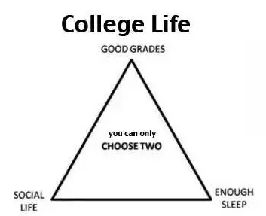

These three aspects make up the three aspects of the game: Social, Work, Health.

The game board, made up of tiles, is equally separated into these three sections.

Players (user/computer) take it in turns to pick a tile from any of these three sections.

Upon picking a tile, the player must roll the dice to determine if the outcome will be either positive or negative.

A dice roll value of 1 – 3 will be a negative outcome.

A dice roll value of 4 – 6 will be a positive outcome.

Players possess qualities such as: money, health points, social points, and current grade.

Work – money, current grade

Health – health points

Social – money, social points

Negative outcomes can affect any of the player’s qualities, for example a player chooses a “work” tile and rolls a 2, the player could receive an effect such as …. “You forgot about a nearby deadline and now have to spend the weekend studying rather than with friends -2 to social”

A negative outcome can be avoided if the player has sufficient funds as spending money can be done to counteract the negative outcome.

A positive outcome will affect the player’s quality, which corresponds to the tile type chosen. For example, a player chooses a work tile and rolls a 4, the player could receive an effect such as…” You got to participate in an Essex Lab study and receive £15 for your spare time!”.

There is a total of 3 rounds in the game (one for each term).

At the start of each round, each player receives £100 (in 2nd and 3rd round this is added to their current balance), this acting as “student finance”.

Each player can choose a maximum of 10 tiles per round (one for each week of the term).

If any of the player’s attributes drop to 0 they automatically lose the game.

If a player’s current grade drops below 40 they automatically lose the game.

# Players

* User
* Computer / “Bot”

# Objectives

The aim of the game is to end up with the highest score overall meaning you won the student games yay!.

A player’s score is calculated by adding up the values for money, health points, social points, and current grade score.

Current grade score:   
+70 = 3

60-69 = 2

50-59 = 1

40-49 = 0

# Tokens

* Player’s money balance (initially £100)
* Player’s health points (starting 100)
* Player’s social points (starting 100)
* Players current grade (starting 63)